**TRIGGERS**

**--1 To update the box office every time a new row is entered for the current weekend**.

If the movie exists in the table, then it calculates the total gross based on the previous entry and assigns 0 to latest column for the previous entry and 1 for the new entry. If the movie does not exist in the table, total gross and the weekly gross are equal to each other, latest column automatically assigned 1 and the week is assigned as 1 as well.

Create trigger BoxOfficeInsert1

on BoxOffice

after insert

AS

BEGIN

SET NOCOUNT ON;

declare

@startdate as date,

@weeklygross as varchar(30),

@movieID as int,

@BOID AS INT;

Select @BOID=BoxOfficeID,@StartDate=WeekendStartDate,@weeklygross=WeeklyGross,@movieID=MovieID from inserted;

Exec BoxOfficeUpdateNewAndOld @ID1=@BOID,@Wgross1=@weeklygross,@Sdate1=@startdate,@MID1=@movieID

end

create procedure BoxOfficeUpdateNewAndOld

@ID1 int,

@Wgross1 varchar(30),

@SDate1 as date,

@MID1 AS INT

as

declare

@rowcount1 int,

@oldTotal1 as varchar(30),

@oldweek1 as int,

@newweek1 as int,

@oldBoId1 as int,

@newTotal1 as int

select @rowcount1=count(*) from BoxOffice

where MovieID=@MID1 AND latest=1;

If @rowcount1=0

begin

update BoxOffice

Set TotalGross=@Wgross1, WeekendEndDate= DATEADD(day,2,@SDate1),Week=1, Latest=1

Where BoxOfficeID=@ID1 and MovieID=@MID1

end

else

begin

Select @oldTotal1=TotalGross,@oldweek1=Week,@oldBoId1=BoxOfficeID from Boxoffice where MovieID=@MID1 and latest=1;

Set @newweek1=@oldweek1+1

set @newTotal1= cast(@oldtotal1 as integer)+ cast(@Wgross1 as int)

Update BoxOffice

Set TotalGross=convert(varchar(30),@newTotal1), WeekendEndDate= DATEADD(day,2,@SDate1),Week=@newweek1, Latest=1

Where BoxOfficeID=@ID1

Update BoxOffice

set latest=0

where BoxOfficeID=@oldBoId1

end

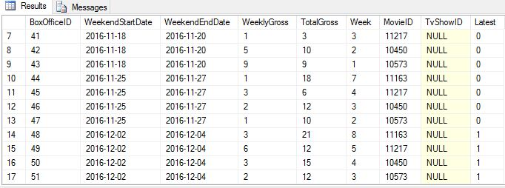

Insert into BoxOffice (WeekendStartDate,WeeklyGross,MovieID)

values ('12/9/2016','5',10573)

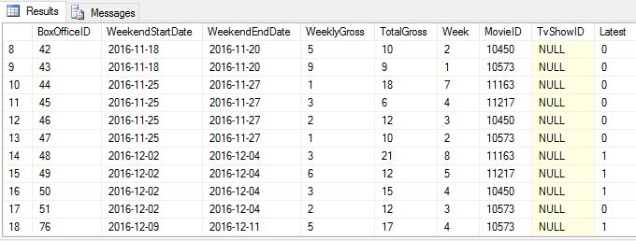

Insert into BoxOffice (WeekendStartDate,WeeklyGross,MovieID)

values ('12/9/2016','5',20)

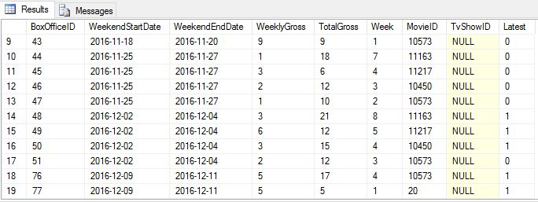

**--2 To update the rating in the movie table every time a rating is given**

When a new rating is given for a movie in the rating table, the movie table is updated. The rating count is increased by one and the rating is recalculated and updated in the movie table.

create trigger RatingandCount

on Rating

after insert

as

begin

declare

@MovieID INT,

@rating int

Select @MovieID= MovieID,@rating=rating from inserted

If @movieid is not null

begin

EXEC UpdateRating1 @MOVID=@MOVIEID,@newrating=@rating

end

end

Create procedure UpdateRating1

@MovID INT,

@NEWRATING INT

AS

BEGIN

DECLARE

@RATINGCOU AS INT,

@PREVIOUSRATING AS INT,

@PREVIOUSTOTAL AS INT

SELECT @RATINGCOU=[Rating count],@PREVIOUSRATING=Rating FROM MOVIES WHERE MovieID=@MovID

Set @PREVIOUSTOTAL=@PREVIOUSRATING*@RATINGCOU

UPDATE MOVIES

set rating= (@PREVIOUSTOTAL+@NEWRATING)/(@RATINGCOU+1)

where MovieID=@MovID

UPDATE MOVIES

SET [Rating count]=@RATINGCOU+1

WHERE MovieID=@MovID

END



Insert into rating(Rating,CustomerID,movieid)

VALUES(300,237,23)

